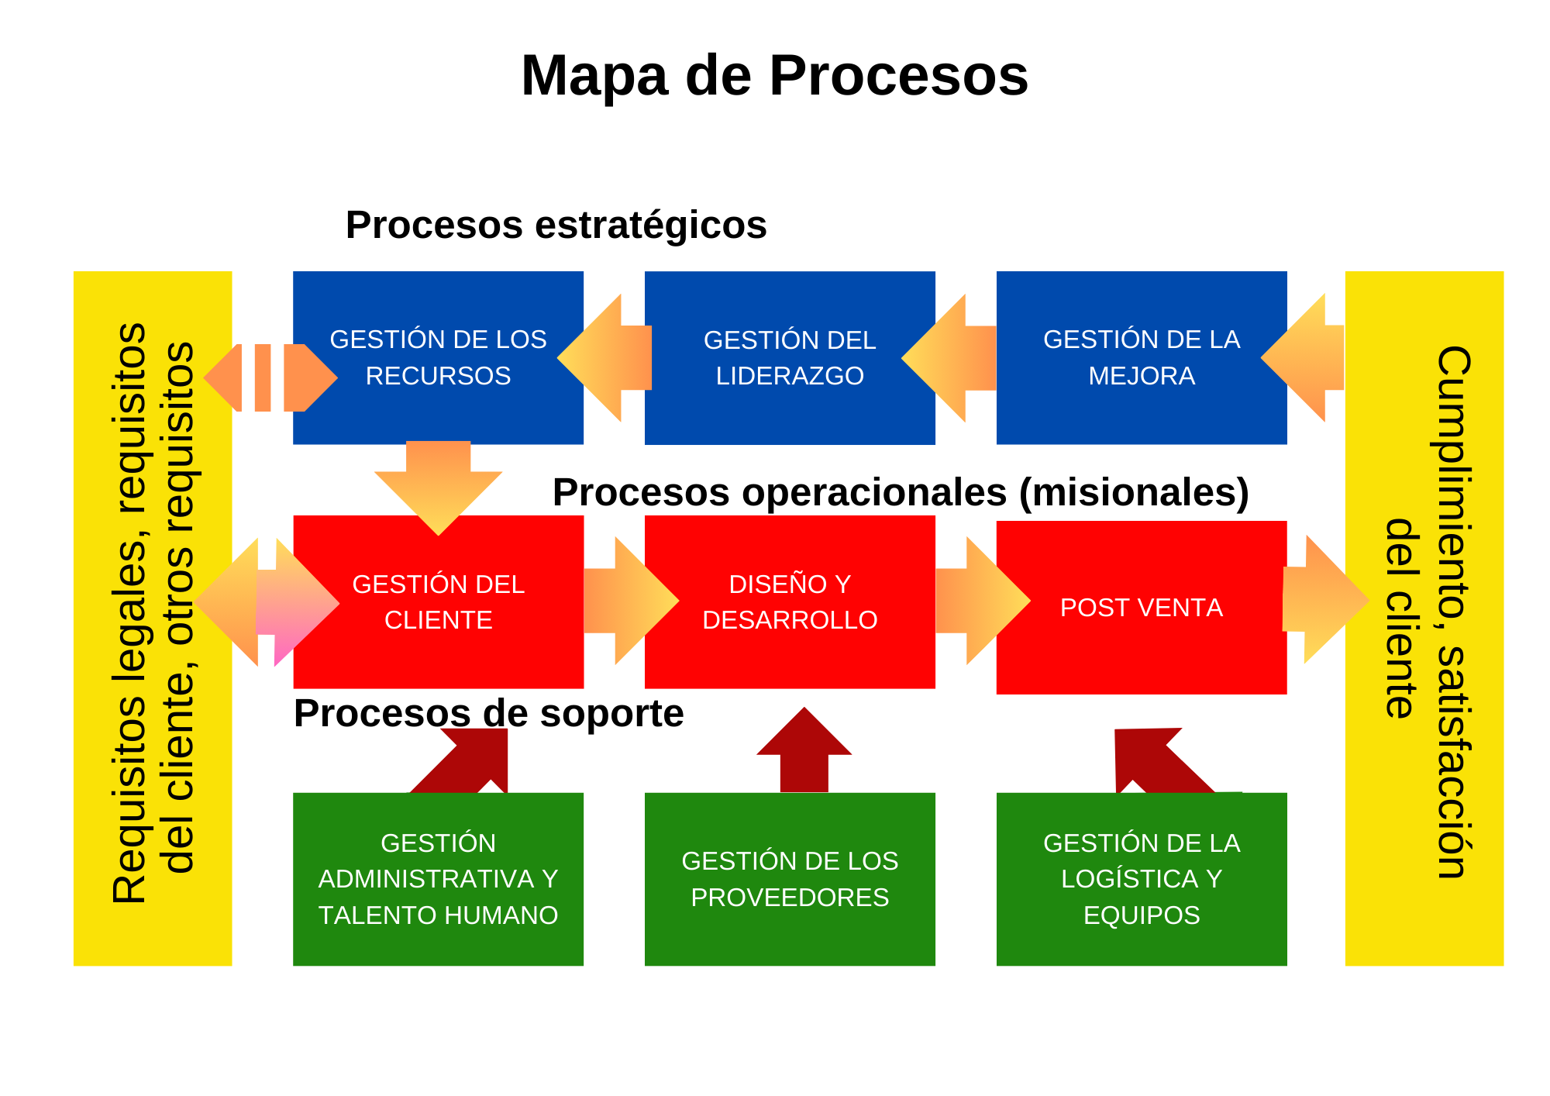

Historial de Versiones

|  |  |  |  |  |
| --- | --- | --- | --- | --- |
| Versión | Fecha |  | Asiento | Aprueba |
| 000 | Fecha: 01.12.2024 |  | Original | CEO |
|  |  |  |  |  |
|  |  |  |  |  |